**Creation And configure IBM cloud service-**

**Create Cloudant database**

|  |  |
| --- | --- |
| **Date** | **15.11.22** |
| **Team ID** | **PNT2022TMID48656** |
| **Project Name** | **IOT based safety gadgets for child safety monitoring and notification** |

**AIM:**

To create Cloudant database

**Step 1:**Login to IBM Cloud with mail ID and password

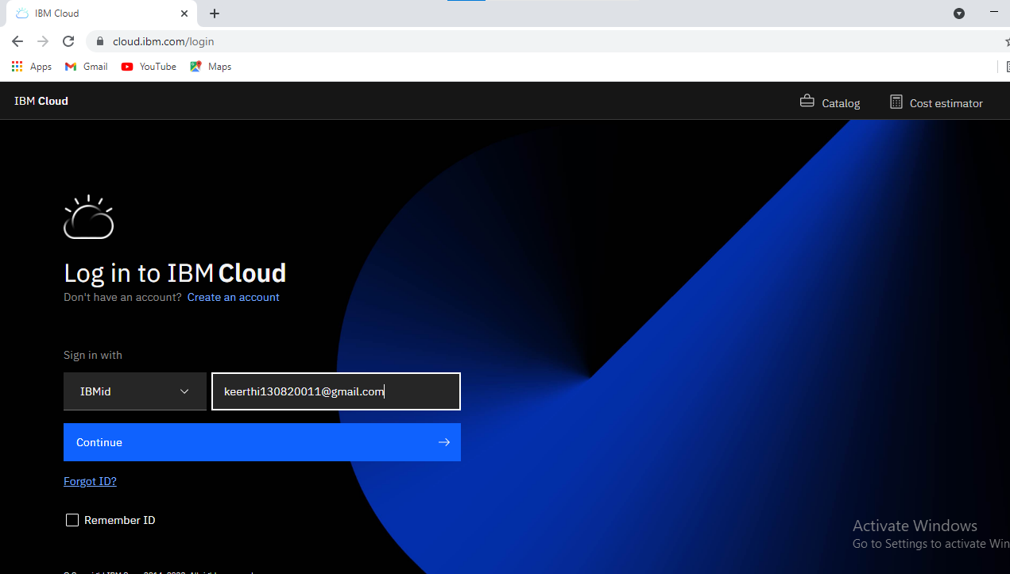

**Step 2:**Go to catalog and search for cloudant ion the search bar

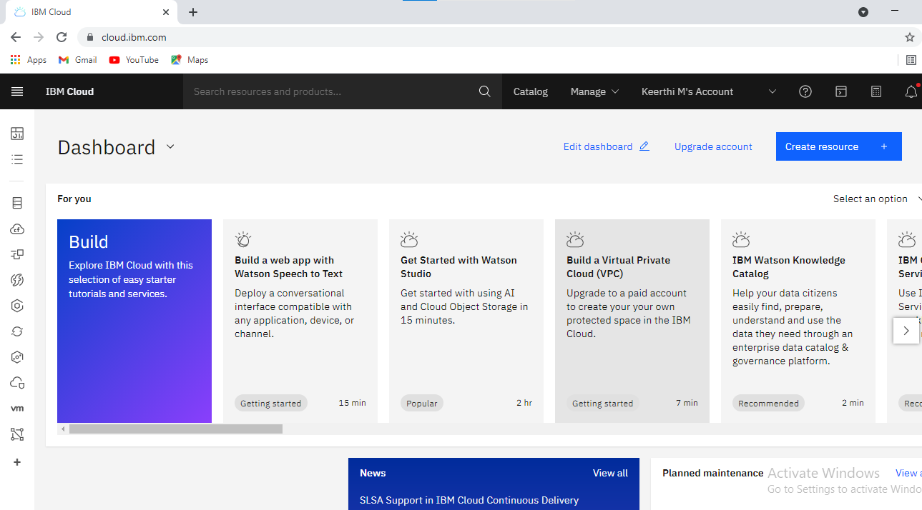

**Step 3:**

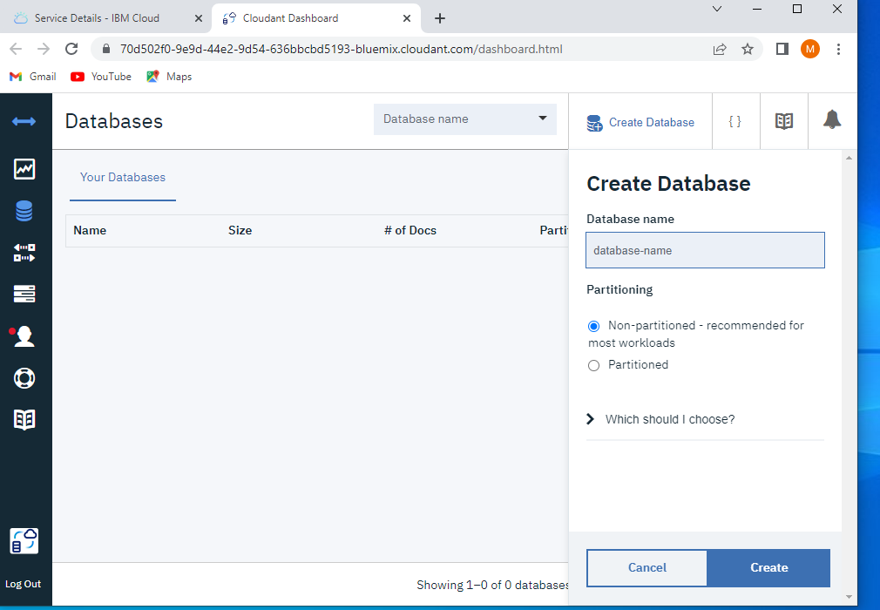

**Step 4:** 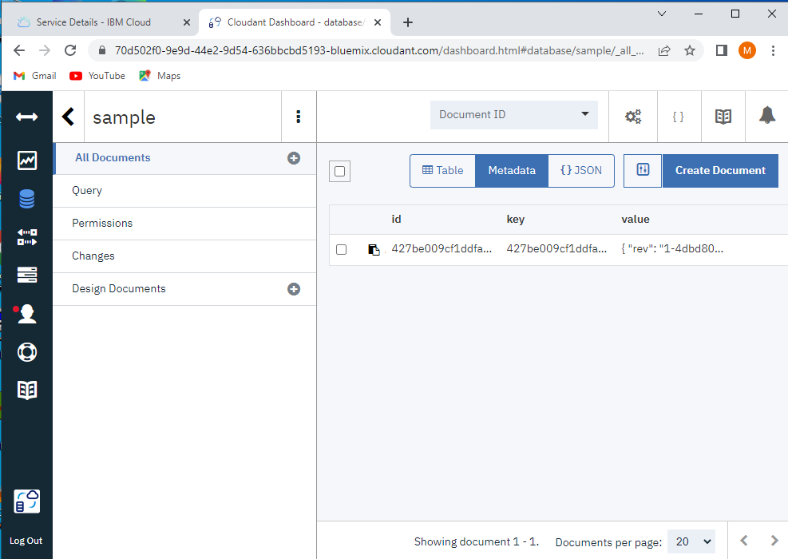

**Step 5:**

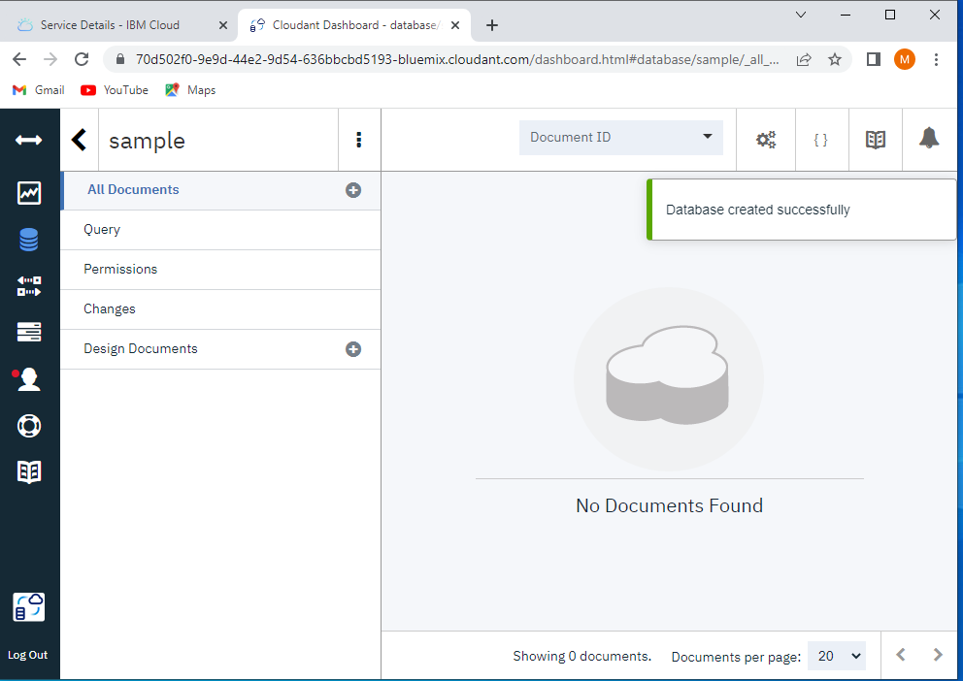

**Step 6:**

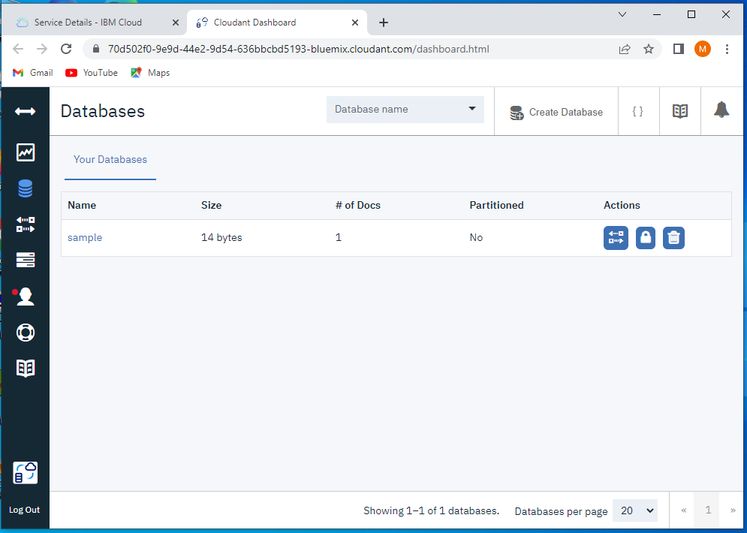

**Step 7:**

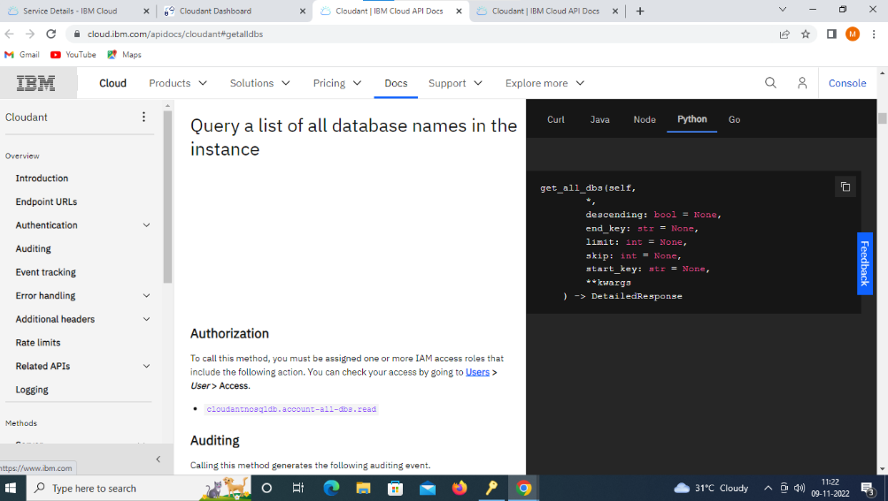

**Step 8 :**Successfully creating the Database

